# Track Changes in Microsoft Word

**Track Changes** is a way of keeping track of the changes we make to a Word document. You can use this tool to accept or reject those changes. For instance, if you create a documesnt and e-mail it to your colleague for feedback, the colleague can edit the document by selecting **Track Changes** from the toolbar. When the colleague sends the document back, you can view the changes they made to your document.

In MS Word, you can use **Track Changes** to keep a track of the changes that are made to the original document. It is also a useful tool if you want to collaborate on a project, as multiple users can make changes to the document, while still retaining the original content.

The **Track Changes** tool is useful if you are working with large documents that are likely to change in future. It might be useful when a group of people are working together on one document and need to keep track of revisions made by other members of the group.

Since **Track Changes** is useful for working with large documents, the tool is primarily used by authors, editors, reviewers, and proof-readers. Moreover, students and researchers can also use it for coursework such as writing dissertations and thesis.

## Using the Track Changes Tool

Perform the following steps to enable **Track Changes** on your Word document:

1. On the access toolbar, click **Review**.

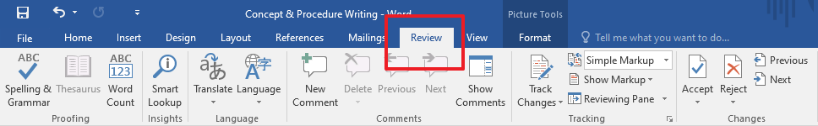

1. Click anywhere on the **Track Changes** button,or click the small downward pointing arrow on thebutton to open the pull-down menu.

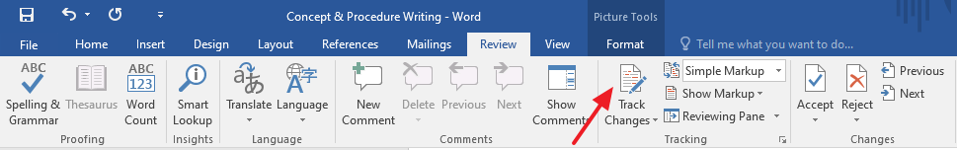

1. The pull-down menu displays the **Track Changes** and **Lock Tracking** options.
2. Click **Track Changes**.

## Accepting changes:

Perform the following steps to accept the changes made to your Word document:

1. On the **Review** panel, click the checkmark icon ✔ to accept all the changes.

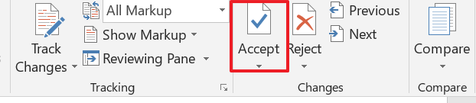

1. Alternatively, click the downward pointing arrow to view the following options:

* Accept and Move to Next
* Accept This Change
* Accept All Changes Shown
* Accept All Changes
* Accept All Changes and Stop Tracking

## Reject changes:

Perform the following steps to reject the changes made to your Word document:

1. On the **Review** panel, click the cross icon ❌ to reject all the changes.

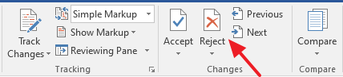

1. Alternatively, click the downward pointing arrow to view the following options:

* Reject and Move to Next
* Reject Change
* Reject All Changes Shown
* Reject All Changes
* Reject All Changes and Stop Tracking

## Turning off Track Changes:

On the access toolbar, if the **Track Changes** button has a dark grey background, it means that the tool is currently set to track changes. To turn off **Track Changes**, click the **Track Changes** button so that it no longer has the dark grey background.